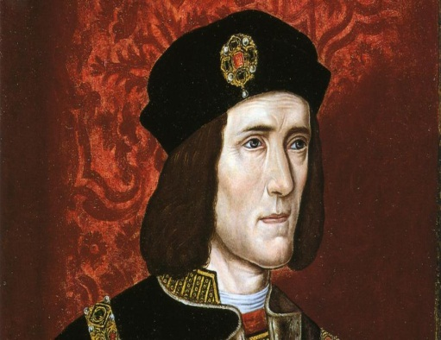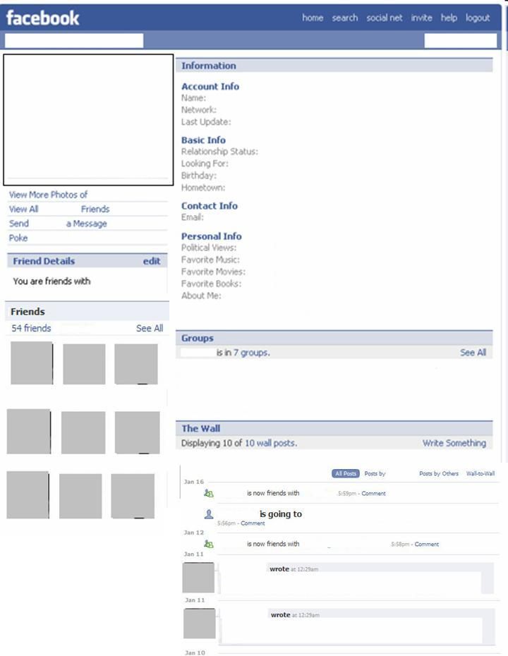

**Rebellion**

**Describe the rebellion against Richard:**

**Was Shakespeare correct about my appearance?**

**How did I claim the English Crown?**

**What did I do when I became King?**

**My Rival to the Throne**

**Name:**

**House:**

**Relationship status:**

**Account Info**

**Personal Info**

**Name:**

**Date of Birth:**

**Date of Death:**

**House (York or Lancaster):**



**Rebellion**

**Describe the rebellion against Richard:**

**Was Shakespeare correct about my appearance?**

**How did I claim the English Crown?**

**What did I do when I became King?**

**My Rival to the Throne**

**Name:**

**House:**

**Relationship status:**

**Account Info**

**Personal Info**

**Name:**

**Date of Birth:**

**Date of Death:**

**House (York or Lancaster):**