Question 1
Express $x^{2}+10x-15$ in the form ${(x+p)}^{2}+q$ .

.......................... (2 marks)
Question 2
Express $x^{2} -6x-81$ in the form ${(x- p)}^{2} +q$ .

.......................... (2 marks)
Question 3
Express ${7-4x-x}^{2}$ in the form $p-{\left(x+q\right)}^{2}$ where $p$ and $q$ are constants.

.......................... (2 marks)
Question 4
Write ${2x}^{2}-8x+9$ in the form $a{\left(x+b\right)}^{2}+c$

.......................... (3 marks)
Question 5
Write ${3x}^{2}-12x+7$ in the form $a{\left(x+b\right)}^{2}+c$

.......................... (3 marks)

Question 6 Solve by factorisation ${2x}^{2}+5x-12=0$

.......................... (3 marks)
Question 7 Solve by factorisation ${3x}^{2}+11x-20=0$

.......................... (3 marks)
Question 8
Solve the equation ${3x}^{2}+9x-2=0$ correct to 1 decimal place.

.......................... (3 marks)
Question 9
Solve the equation ${10x}^{2}+3x-11=0$ correct to 1 dp.

.......................... (3 marks)
Question 10
Solve $\frac{3}{x-2}+\frac{2}{x-1}=5$ Do not use trial and improvement.
Write your solutions to 3 significant figures.

.......................... (6 marks)

Question 11
Solve $x^{2}+8x+6=0$ by completing the square.
Give your answer in the form $a±\sqrt{b}$ , where $a$ and $b$ are integers.

.......................... (4 marks)
Question 12
Solve $x^{2}+6x+2=0$ Give your answer in the form $a±\sqrt{b}$ where $a$ and $b$ are integers.

.......................... (4 marks)

Question 13
Use the discriminant to determine the nature of the roots of the function $f\left(x\right){=7x}^{2}+5x-1$

.......................... (2 marks)

Question 14
Determine the nature of the roots of the equation
${3x}^{2}-2x+7=0$
[ ] "two real and distinct roots"
[ ] "one real repeated root" / "equal roots"
[ ] "no real roots"
Question 15
Find the value of $q$ for which the equation ${qx}^{2}-6x+18=0$ has one repeated real root.

$q=$ ..........................
Question 16
A curve has the equation ${y=2x}^{2}-8x-5$ .
Find the coordinates of the point where the curve intercepts the $y$ -axis.

.......................... (1 mark)

Question 17
Below is a sketch of the graph with equation ${y=x}^{2}-3x-18$ .
Work out the values of $a$ and $b$ .
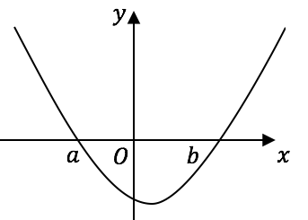
..........................

Question 18
Sketch the graph of $y =(x-6)(x+4)$ .
On your sketch, show clearly the points of intersection with the $x$ -axis and the $y$ -axis, and the coordinates of the turning point.

(2 marks)

Question 19 This is a sketch of the graph of $y=\left(x-1\right)\left(x-3\right)$ .
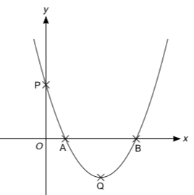
Work out the coordinates of the turning point Q.

.......................... (3 marks)
Question 20
You are given that $x^{2}+6x+2≡{\left(x+3\right)}^{2}-7$
Write the coordinates of the minimum point on the curve ${y=x}^{2}+6x+2$

.......................... (1 mark)
Question 21
The curve $C$ has equation $y=3-5{\left(x+1\right)}^{2}$
The point $A$ is the maximum point on $C$. Write down the coordinates of $A$ .

.......................... (1 mark)

Question 22
By completing the square, find the coordinates of the turning point of the curve with equation ${y = x}^{2} + 10x + 18$ You must show all your working.

.......................... (3 marks)

